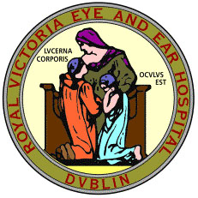

ROYAL VICTORIA EYE AND EAR HOSPITAL

Clinical Audit Registration Form
AUDIT TITLE:
REASONS FOR CHOICE OF AUDIT:
National priority-

Local priority-
AUDIT OBJECTIVES:
AUDIT STANDARDS:
(Continue on a separate sheet if necessary)
Standard of care Exception

CONSULTATION:
Will the audit involve patients?
Will the audit involve other healthcare professionals?
Will the audit involve other organisations?

If yes to any of the above, has their agreement been obtained to carry out the audit?
AUDIT METHOD: DATA SOURCE
Data collection proforma Healthcare records
Questionnaire Computer held information
Interview Patient experience
Other Other

DATA SOURCE: Prospective PROPOSED SAMPLE SIZE:
Retrospective

Proposed start date: Proposed end date:

How do you intend to share the audit results:
___________________________________________________________________________________________________________________________________________________________________________________________________________________________

CONSULTANT SUPERVISOR:___________________________

DEPARTMENT:________________________________________

SIGNATURE OF PROJECT LEAD:________________________

DATE:_________________________________________________

NAME OF MAIN CONTACT FOR PROJECT:___________________________

EMAIL ADDRESS:_________________________________________________

MOBILE NUMBER/BLEEP:_________________________________________

SIGNATURE:_____________________________________________________

DATE____________________________________________________________

Please return the completed form to:

Ms Úna Nugent
Education & Conference Centre
Royal Victoria Eye & Ear Hospital
Adelaide Road
Dublin 2

una.nugent@rveeh.ie
01-6343659

Office use only
Date Received:__________________________

Signed by:______________________________

